William Pring

Student ID:6919764

Description Of Process

In this project I will be using a cookie machine to representing my hypothetical industrial environment. It going to have a dough machine, baking machine, packaging machine and a sealing machine for the shop floor. It will also have a central computer that will log the data that is being transmission. Lastly the central computer will also have the ability to communicate to any device and ask them for their status and be able to receive a respond.

System Block Diagram

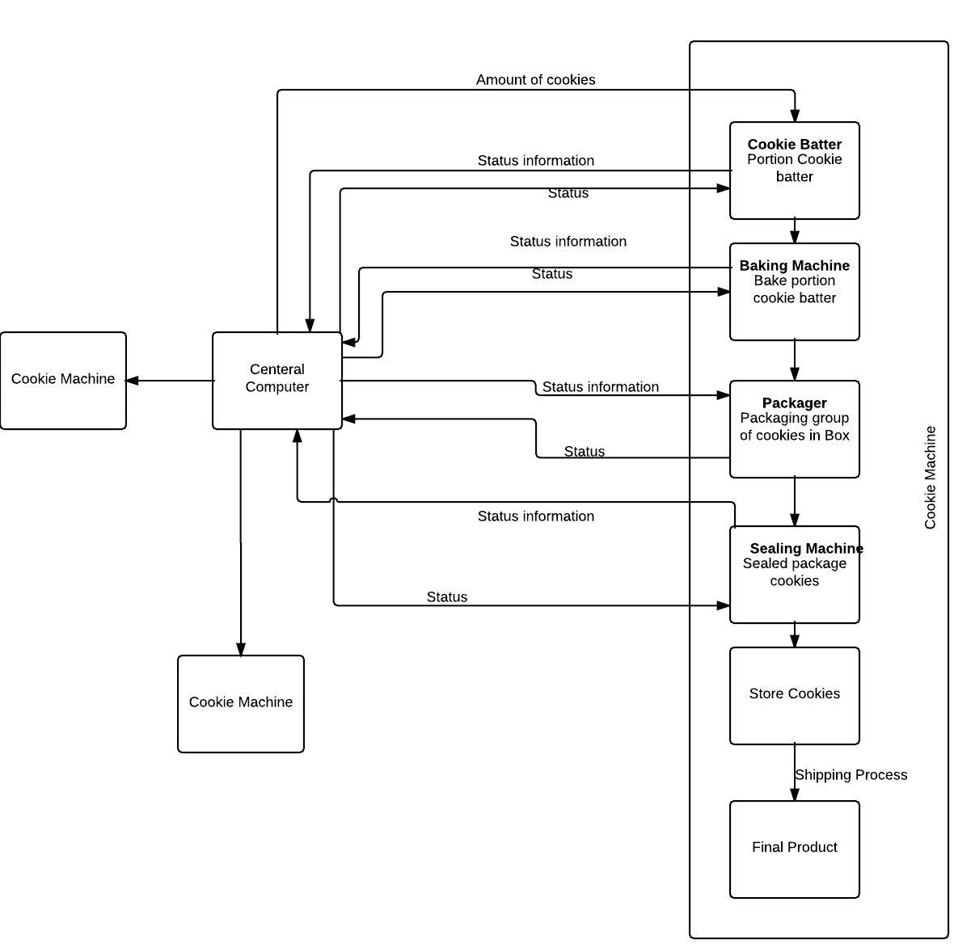

Description of RS485

RS485 are a serial communication that is widely use in devices, automation systems and computers. It is a balanced line, half-duplex transmission system allowing transmission distance of up to 1.2 km. (Limited) RS485 is one of the most widely used communication interfaces in data acquisition and control application because it is the most versatile communication and performs well on all four points. (Bies, 2015) RS485 offer data transmission speeds of 35 Mbit/s to 10 m and 100 kbit/s at 12000m. (RS-485, 2015)<https://conestoga.desire2learn.com/d2l/lp/documents/almISyJYhhWwT43kX9032018516/5/6>

**DFD**

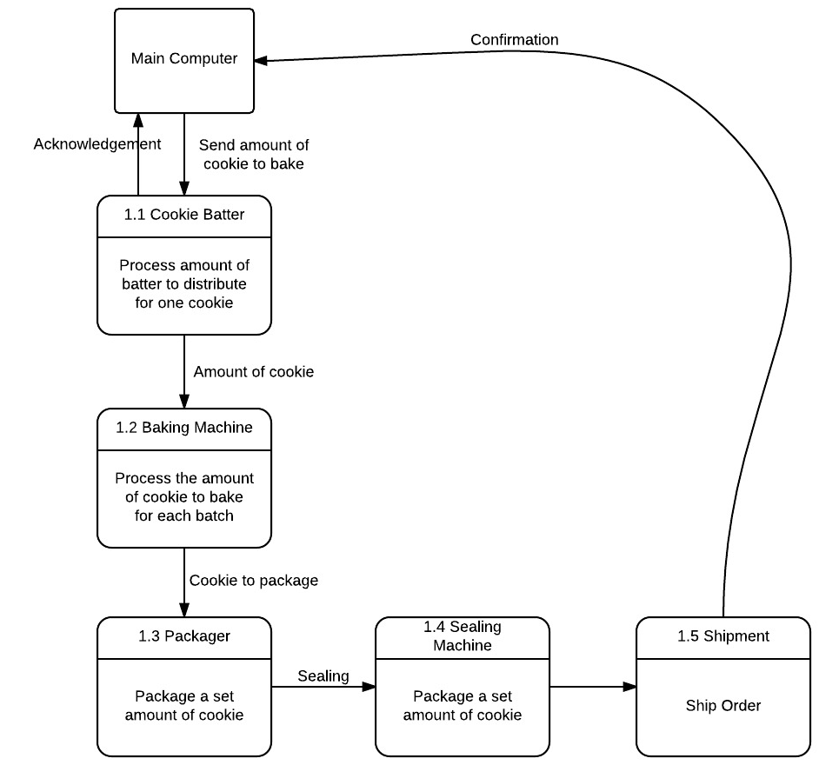

**Flow Chart**

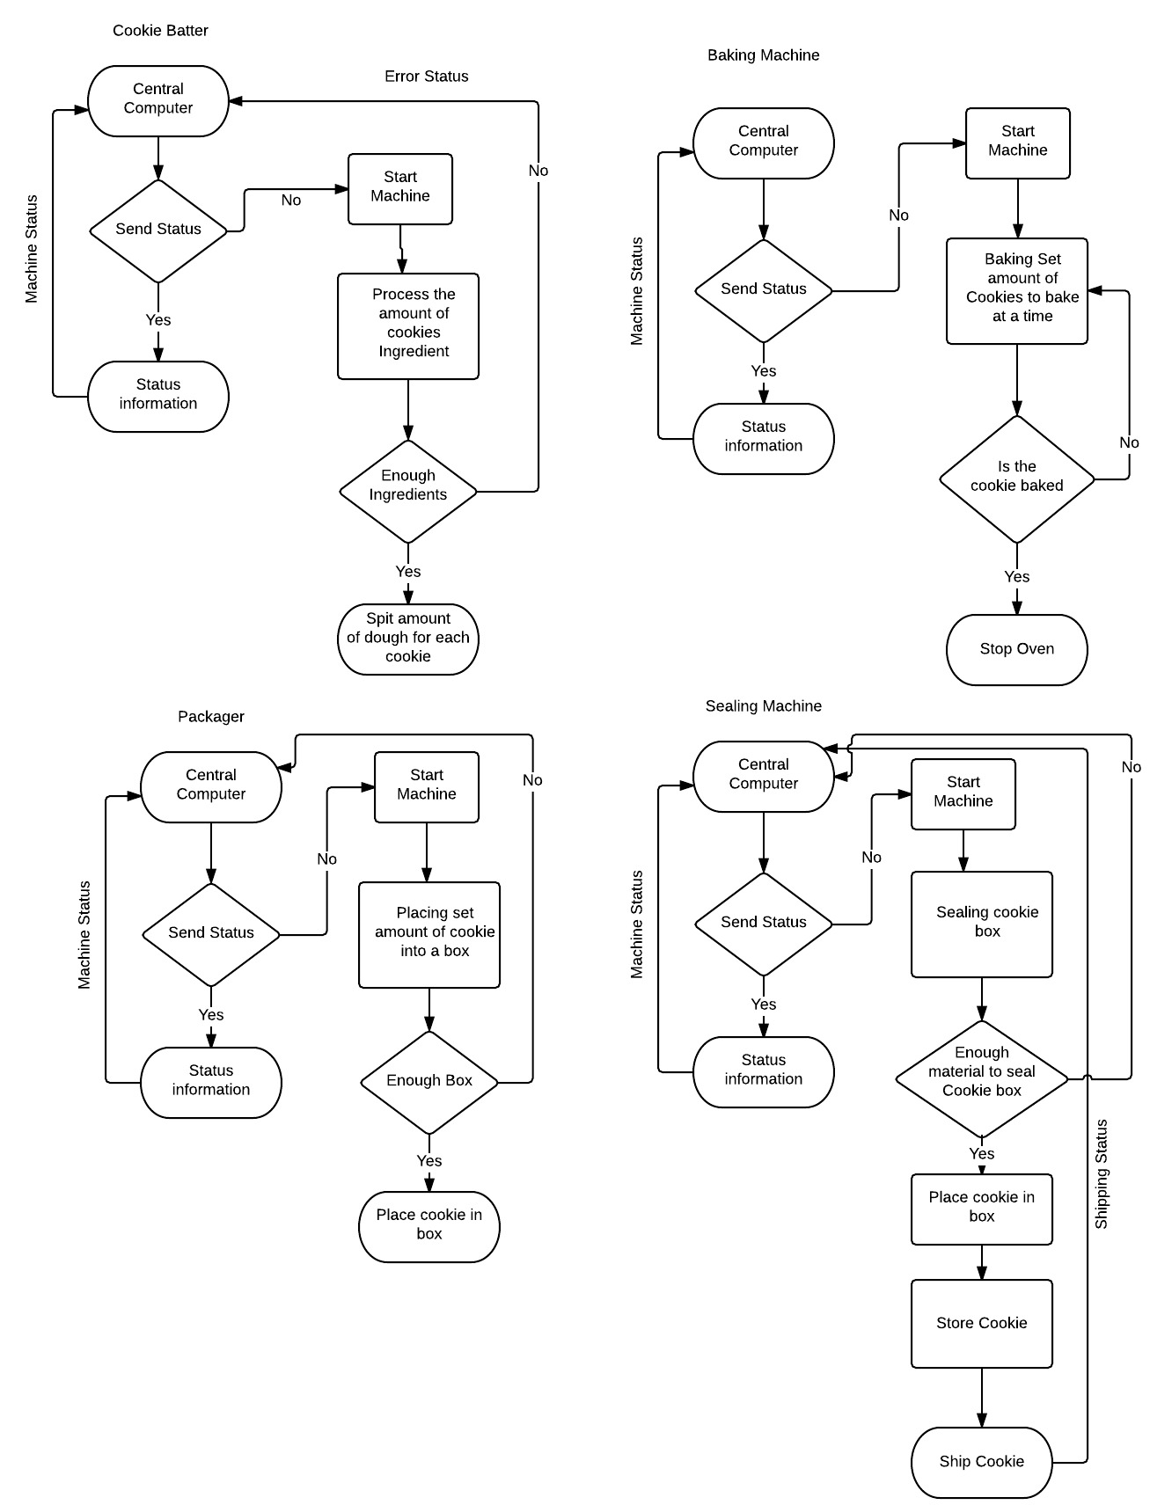

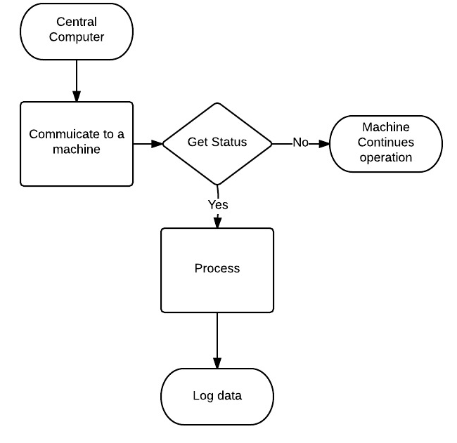

Protocol Details

The protocol will have a specific format in how the message will be request and receive. The message request will allow server to request information about a particular machine. The request machine will send a message which will be a string that has a length of 6. The first element in this string will represent the machine floor (This is assuming that there will be less than nine floors that it will be communicating to). The string element two, three and four will represent the machine number with padding of zeros (001). By doing this you will be able to address any of the 1-100 machine that you wish you communicate to. String element 5-6 will be a two letters that will be representing the machine (CB- Cookie Batter, BM- Baking Machine, PK Packager, SM – Sealing Machine).

The server will receive is a string that has a length of 8. The first element in this string will represent the machine floor (This is assuming that there will be less than nine floors that it will be communicating to). The string element two, three and four will represent the machine number with padding of zeros (001). By doing this you will be able to address any of the 1-100 machine that you wish you communicate to. String element 5-6 will be a two letters that will be representing the machine (CB- Cookie Batter, BM- Baking Machine, PK Packager, SM – Sealing Machine). String element 7 will represent that status of the machine (N – Normal, E- Error). Element 8 will be empty if there are no problems. If there is an error element 8 will have a specific error letter which will represent a specific error (I – Ingredients, E – Enough Boxes, S – Sealing Material).

|  |  |  |  |
| --- | --- | --- | --- |
| Document | | Self Evaluation | Score |
|  | Completeness | 5/ 5 | / 5 |
|  | Format | 5/ 5 | / 5 |
|  | Clarity / Writing | 4/ 5 | / 5 |
|  | References | 5/ 5 | / 5 |
| Document Total | | | / 20 |
| Content | | Self Evaluation | Score |
|  | Process Description | 4/ 5 | / 5 |
|  | Block Diagram | 4/ 5 | / 5 |
|  | RS485 Description | 5/ 5 | / 5 |
|  | Data Flow Diagram | 5/ 5 | / 5 |
|  | Data Acquisition Flowchart | 5/ 5 | / 5 |
|  | Protocol Details | 5/ 5 | / 5 |
| Content Total | | | / 30 |
| Reflection | | Self Evaluation | Score |
|  | Self Evaluation Accuracy | 5/ 5 | / 5 |
| Report Total | | | / 55 |

# References

Bies, L. (2015, April). *RS485 serial information*. Retrieved from lammertbies: http://www.lammertbies.nl/comm/info/RS-485.html

Limited, T. E. (n.d.). *RS485 & Modbus Protocol Guide.* UK.

*RS-485*. (2015, December 26 ). Retrieved from Wikipedia: https://en.wikipedia.org/wiki/RS-485